*The Business Plan Development*

*Company: Hayai Desire*

*Name: Naazim Changani*

*Course: Entrepreneurship*

*Professor: Philip J Brand*



Owner: Naazim Changani

Email: Hayaidesire@gmail.com

## Executive Summary

Hayai Desire is a delivery platform that partners with so-called shoppers to deliver groceries within hours of an order. Hayai Desire partners with over 30 retailers across the Unties States and Canada.

Hayai Desire operates as a same-day grocery delivery service company. Hayai Desire allows customers to select groceries through an online application also payments can be made by crypto-currency platform from various retailers and have them delivered by personal shoppers.

Hayai Desire makes money via commission, delivery fees, a premium subscription service, as well as advertising within the app.

Hayai Desire is a food delivery and pick-up platform, deliveries can be schedules for as little as an hour ahead. Alternatively, orders can also be made for deliveries in over a week.

Since Hayai Desire doesn’t store or sell groceries themselves, the shoppers will notify users in the app if something you’ve purchased is out of stock or not available.

Customers can access the platform via Hayai Desire website as well as its smartphone apps on Android and iOS respectively.

Founded in 2022 and headquarter in San Francisco, Hayai Desire will grow to compete with leaders in grocery delivers. It has raised over $60,000 in funding while being valued at $90,000.

Table of Contents

Executive Summary i

List of Tables iv

List of Figures v

1. Introduction 1

1.1. Value Proposition 1

1.2. Business Concept 2

1.3. Vision 3

1.4. Mission 3

1.5. Values 3

1.6. Major Goals 4

2. Operating Environment 5

3. Operations Plan 6

3.1. Operations Timeline 8

3.2. Start-Up 8

3.3. Risk Management Strategies 10

3.4. Operating Processes 11

3.5. Facilities 14

3.6. Organizational Structure 15

4. Human Resources Plan 17

4.1. Leadership and Management Strategies 17

4.2. Recruitment and Retention Strategies 18

4.3. Training 19

4.4. Performance Appraisals 19

4.5. Health and Safety 19

4.6. Compensation 20

4.7. Key Personnel 21

5. Marketing Plan 22

5.1. Market Analysis 22

5.2. Competitive Analysis 22

5.3. Organizational Analysis 24

Strengths – Hayai Desire 25

Weaknesses – Hayai Desire 26

Opportunities – Hayai Desire 27

Threats – Hayai Desire 29

Core Competencies 31

5.4. Marketing Strategy 32

6. Financial Plan 38

6.1. Overview 38

6.1. Proforma Income Statements 39

6.2. Proforma Balance Sheets 40

6.3. Proforma Cash Flow Statements 41

6.4. Investment Analysis 44

6.5. Projected Financial Ratios and Industry Standard Ratios 44

6.6. Break-Even Analysis 45

6.7. Critical Success Factors 46

7. References 47

Appendix 1. Owner Biographies 48

Appendix 2. Product Pictures 48

# List of Tables

Table 1. Fixed Capital Requirements for Start-Up 10

Table 2. Start-Up Expenses 10

Table 3. Risk Management Strategies 11

Table 4. Projected XXX Purchases for Years 1-4 13

Table 5. Projected XXX Summary for Years 1-5 13

Table 6. Competitor Analysis 21

Table 7. Promotional Plan Years 1-2 27

Table 8. Projected xxx Years 1-3 29

Table 9. Projected xxx Summary for Years 1-5 29

Table 10. Projected Income Statements 32

Table 11. Projected Balance Sheets 33

Table 12. Year 1 Projected Cash Flow Statement 34

Table 13. Year 2 Projected Cash Flow Statement 35

Table 14. Year 3 Projected Cash flow Statement 36

Table 15. Projected Financial Ratios 37

Table 16. Break-Even Analysis 38

* Be certain that every table, figure, and appendix included in the plan is referenced within the text of the plan so the relevance of each of these elements is clear to the reader.
* Using the *references* feature in Word, list your tables in this section along with the pages on which they are located.

# List of Figures

Figure 1. Workflow Diagram 7

Figure 2. Operations Timeline – Sample 1 8

Figure 3. Operations Timeline – Sample 2 8

Figure 4. Retail Store Layout 14

Figure 5. Organization Chart 15

Figure 6. Positioning Map 21

Figure 7. Break-Even Analysis 37

## Introduction

Hayai Desire is an online ordering solution for grocery shoppers. Users create an Hayai Desire account, order groceries from local stores either via desktop or their mobile device, an Hayai Desire ‘picker’ assembles the order, and then Hayai Desire facilitates a home delivery or an in-store pickup.

The major advantage of Hayai Desire is that it taps into shoppers exiting brick-and-mortar retail preferences. Shoppers know exactly what items their local stores typically tend to stock, and Hayai Desire makes the acquisition of these tried-and-tested item easy.

### Value Proposition

The idea behind creating Hayai Desire was not to earn money or just open a company. The reason why Hayai Desire was born was the need to fulfill the grocery requirements of users without the hassle of going to a crowded store. Hayai Desire fulfills a need a in the market that has not been catered to yet.

* A well-established network of well-known supermarkets.
* No need for warehousing and storage.
* Multiple sources of inventory.
* Instant delivery within two hours.
* Workers willing to work flexibly without have full-time employment.
* The ability to shop from multiple stores at one place.

Users:

User have an app from where they can order groceries by choosing one or more stores.

They can even order from a desktop or laptop using a web-based interface or mobile app.

Users pay online for their order and can tip their shopper in advance during check out.

Option to shop from any of the available stores in nearby. You can place the order with combining items from different stores.

Users can schedule orders for a specific day and time.

Shoppers:

Shoppers receive orders on their smart phones.

Shoppers are stationed near the stores in order to save time.

They pick up the ordered items manually and deliver it to the customer.

Apart from the per hour pay, shoppers often get a tip from customers.

Stores:

Hayai Desire has tie-ups with major superstores in various cities.

These stores have been able to increase their revenue through online sales via Hayai Desire.

### Business Concept

The name Hayai Desire came because when I first arrived to Canada, I don’t know the local grocery store and since I am a student I needed to focus on college, thus the name implies fast groceries at your door step without the hassle of going to stores and waiting at checkout.

The business concept for Hayai Desire was not to make money but to provide a solution to the gap in the market and fulfilling the requirement of customers’ needs and demand.

Process of order fulfilment

1. The process starts with the grocery requirement of the user.
2. These users go on the app to buy groceries by selecting their current location. They then go on and order items from any and all stores near them using online payment methods or crypto-currency.
3. The order is then communicated to the shopper who starts gathering items manually.
4. The personal shopper then goes to deliver the groceries to the customers on their mentioned address.
5. The users can then tip the shopper if they wish to.

Apart from this, the app provides flexibility as it also allows the consumers to pick their order from the store. In this case, a shopper will collect all the items for you and whenever you reach the store your order will be ready for you.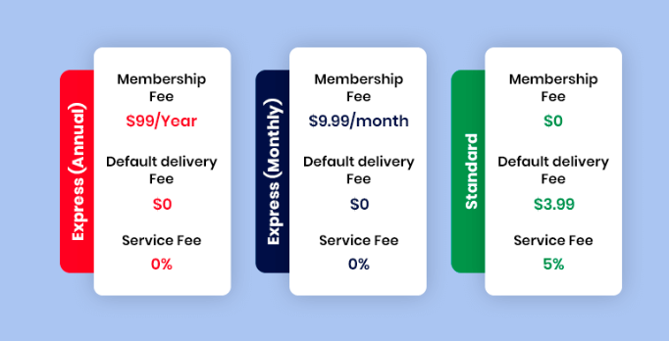

### Vision

The vision of Hayai Desire is to be the leading provider of online food and groceries delivery solution and to continually develop results driven strategies designed to meet specific customers and stakeholders need. We will fulfill this vision by having:

* A driven team: A culture that inspires people to achieve beyond what they thought possible.
* A collaborative environment: always encouraging collaborative and innovative thinking to create measurable solutions for each customer and stakeholders.
* A focused goal: Every team member understands how their contribution plays a part in our growth path.

### Mission

Hayai Desires values to serve generously extends to the communities where we live and work. We’re on a mission to create a world where everyone has access to the food they love, and partnering with great non-profits helps us make that a reality.

### Values

Hayai Desire core values bleed into every aspect of the business and provide a foundation for behaviour, attitude, and decision making. These values define our culture and express the mentality and behaviours necessary for Hayai Desire to exist and achieve our goals.

**Teamwork:** mutual respect, collaboration, always offering support for one another.

**Everyone has a voice:** transparency, all team members regardless of rank are encouraged to provide insight.

**Excellence:** an unwavering desire to achive set goals while maintaining focus on vision and values.

**Attention to details:** a focused alterness, always digging deeper, perfectioneven in the smallest tasks.

**Growth:** alwas focused on company growth, team growth and personal development.

**Balance:** maintaining a balanced life and allows for mental and physical wellness.

### Major Goals

1.Getting and Staying Profitable

Maintaining profitability means making sure that revenue stays ahead of the costs of doing business. Focus on controlling costs in both production and operations while maintaining the profit margin on products sold.

2. Productivity of People and Resources

Employee training, equipment maintenance and new equipment purchases all go into company productivity. Your objective should be to provide all of the resources your employees need to remain as productive as possible.

3. Excellent Customer Service

Good customer service helps you retain clients and generate repeat revenue. Keeping your customers happy should be a primary objective of your organization.

4. Employee Attraction and Retention

Employee turnover costs you money in lost productivity and the costs associated with recruiting, which include employment advertising and paying placement agencies. Maintaining a productive and positive employee environment improves retention.

5. Mission-driven Core Values

Your company mission statement is a description of the core values of your company. It is a summary of the beliefs your company holds in regard to customer interaction, responsibility to the community and employee satisfaction. The company's core values become the objectives necessary to create a positive corporate culture.

6. Sustainable Growth

Growth is planned based on historical data and future projections. Growth requires the careful use of company resources such as finances and personnel.

7. Maintaining a Healthy Cash Flow

Even a company with good cash flow needs financing contacts in the event that capital is needed to expand the organization. Maintaining your ability to finance operations means that you can prepare for long-term projects and address short-term needs such as payroll and accounts payable.

8. Dealing with Change

Change management is the process of preparing your organization for growth and creating processes that effectively deal with a developing marketplace. The objective of change management is to create a dynamic organization that is prepared to meet the challenges of your industry.

9. Reaching the Right Customers

Marketing is more than creating advertising and getting customer input on product changes. It is understanding consumer buying trends, being able to anticipate product distribution needs and developing business partnerships that help your organization to improve market share.

10. Staying Ahead of the Competition

A comprehensive analysis of the activities of the competition should be an ongoing business objective for your organization. Understanding where your products rank in the marketplace helps you to better determine how to improve your standing among consumers and improve your revenue.

## Operating Environment

Hayai Desire operates as a platform connecting shoppers and customers and therefore dones’t own any warehouses, inventory or run their own delviery system. The method relieson:

Users placing their order via the app or the web based interface. They pick the desired store, products and replacement and finally chose a convenient data and time for the delivery.

The shoppers receiving the orders and manually collecting the product in the physical store and delivering those to the user.

Payment is performend throught the Hayai Desire app after the user recevies the products and can include a tip for the shopper.

The model is agile per shifing demand and is asset light technology enabling to create fast and efficient connections between shoppers and users.

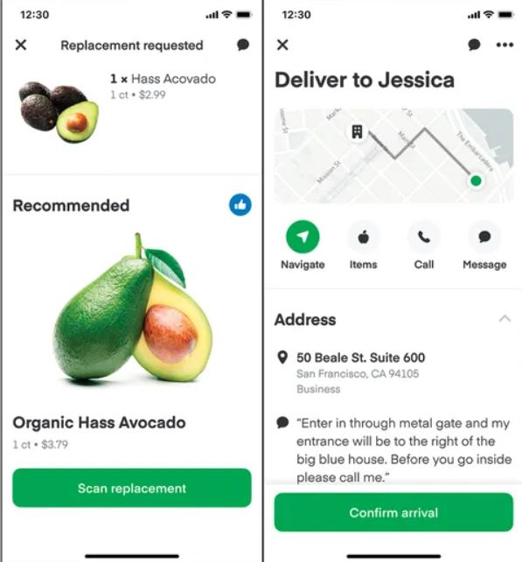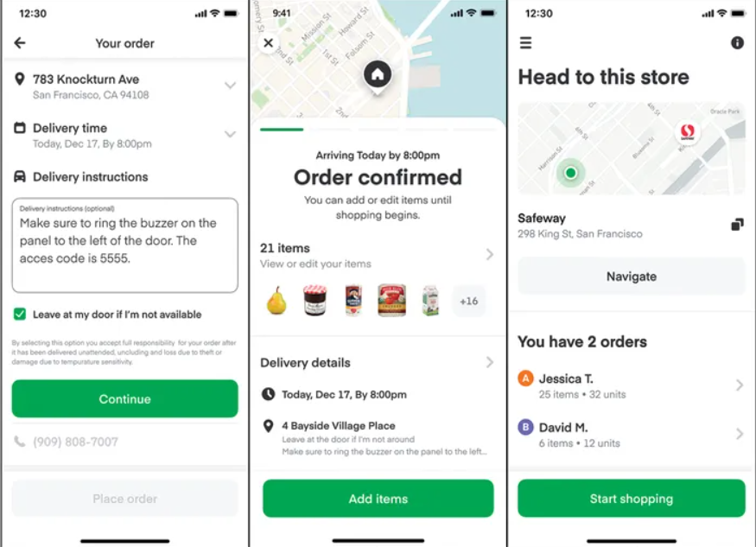

## Operations Plan

Hayai Desire will be corporation and the organization will be not-for profit organization.

* Facility plans
  + Hayai Desire headquarters will be San Francisco a
  + Hayai Desire facility size will be 19,000 square feet as it’s a start-up company and will grow with time and effort.
  + The lease price for office space will be $70,000
  + Utility will cost $35, parking will cost $20, insurance will cost $50 and maintains will cost $20
  + Hayai Desire expansion plan will be included in the office lease for when the company grows and requires more space additional space can be taken for the building.
  + Since Hayai Desire will not have any inventory, they will be no issue, however power-cut and internet issues will affect and plan can be implemented for it

**Workflow**

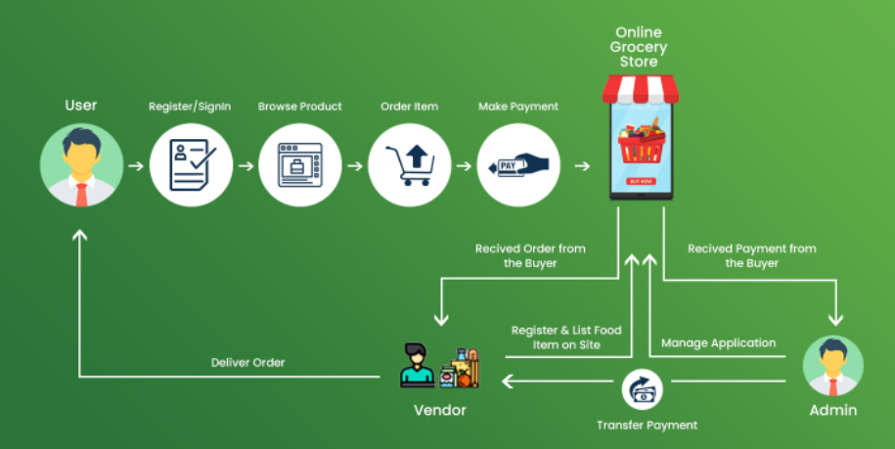

Figure 1. Workflow Diagram

Hayai Desire will maintain the website and mobile app also the payment process, The Tracking of users will be outsourced to Google maps for actuary pinpointing the user address.

### Operations Timeline

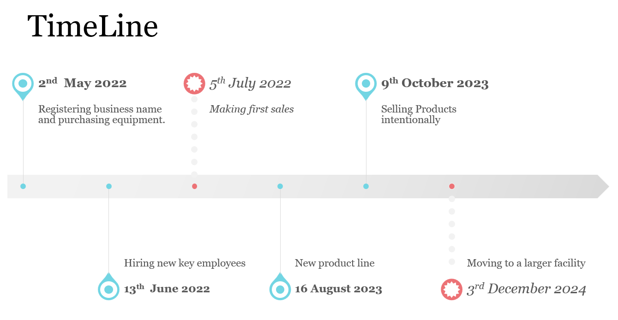

Figure 2. Operations Timeline

### Start-Up

One-time startup business costs are those costs that will most likely be relevant only in the early on startup process such as the expenses for registering the business, or maybe a cost to cover the equipment purchase you need. This means that the costs for that time-frame will obviously be higher but shall dip the following month as it was a “one time cost”.

Ongoing costs are exactly what it says they are. They are costs that are re-occurring. These types of expenses are predictable as they are usually payroll expenses, or utilities and they don’t often fluctuate.

Essential startup costs are costs associated with starting a business and costs that are absolutely necessary for the business to sustain and grow. online ecommerce store, an essential cost would be website development or marketing.

#### Fixed Capital Requirements

|  |  |  |  |
| --- | --- | --- | --- |
| Fixed Capital Requirements for Start-Up (prices shown include taxes) | | | |
| Depreciable Asset | Source | Quantity | Total Cost |
| Rent | Office lease in San Francisco | 1 | $70,000 |
| Computer costs | Source Office Computer Apple Mac | 10 | $7500 |
| Chairs for office (Oliver mid-back swivel) | Source Office Furnishings online catalogue | 10 | $3,085 |
| Equipment | Office equipment | 15 | $20,000 |
|  |  |  |  |
| Total Fixed Capital Requirements for Start-Up (including taxes) | | | $100,600 |

Table 1. Fixed Capital Requirements for Start-Up

#### Start-Up Expenses

|  |  |  |
| --- | --- | --- |
| Start-Up Expenses | | |
| Cost | Source |  |
| Corporate Registry Fees (for-profit entities) | ICS  <https://www.isc.ca/CorporateRegistry/Fees/Pages/default.aspx#CR-FP-NRS>   * Registration of Business Name $50 * Incorporation fee $235 * Company Name and Trade-mark search $60 | $345 |
| Website design | Domain name (requires monthly renewal cost of $25) | $2000 |
| Insurance | Office space, equipment inurance | $4000 |
| Payroll | Empoyement cost | $3000 |
| Legal | Legal protection and patent model fee | $1500 |
| Logo design | Physical and digital logo for the company | $1000 |
| Marketing | Using marketing to attract customers | $6000 |
| Training | Employees training cost | $5000 |
| Total Start-Up Expenses (including taxes) | | $22,850 |

Table 2. Start-Up Expenses

### Risk Management Strategies

Hayai Desire can manage risk exposure by addressing individual sources of risk with detective and preventive measures that either reduce the probability of the risk occurring or reduce its potential negative impact to the business.

Hayai Desire is also adopting software-based compliance management tools that manage risk exposure by automating compliance workflow across the organization.

**Isolating Identified Risks**

Information technology teams are used to engaging with internal or external help to isolate security gaps or flawed processes that might leave room for vulnerabilities. In doing so, they become proactive in identifying security risks ahead of an event rather than waiting for a malicious and costly breach to occur.

**Building in Buffers**

Whether it’s a technology or audit project, project managers recognize the need to build in a buffer. Buffers reduce risks by ensuring initiatives stay within the intended scope. Depending on the project, buffers may be financial, resource or time-based. The goal here is making sure that there are no surprises posing unforeseen risks.

**Contingency Planning**

Things seldom go as planned, and while having a plan is great, it’s seldom enough. Companies need to plan to have multiple plans or options based on various scenarios. Contingency planning is all about anticipating that things will go wrong and planning alternate solutions for the type of risks that may surface and foil your original plan.

* + Avoiding –The use of a piece of faulty equipment, but only if it isn’t needed and it doesn’t impact performance, productivity, or safety, however there should be a re-evaluation to find other sustainable risk responses to address the underlying issues.
  + Reducing –Attempts to deal with risk by preventing the loss or reducing the chances that it will occur.
  + Transferring – The lack of expertise or training required to address risks, it may be a good idea to outsource or transfer the risk to another party.
  + Accepting (assuming) –The change of vendor pricing or delivery down the road, its important to keep re-evaluating these types risk periodically their impact on Hayai Desire and its projects could change.

|  |  |  |  |
| --- | --- | --- | --- |
| **Risk Exposure** | **Risk Consequence** | **Risk Potential** | **Mitigation** |
| Fire, flood, theft | Possibly devastating | Moderate | Purchase insurance and monitoring system |
| Bad debt | Lost income and profit | Moderate | Credit checks, registered security, legal contracts |

Table 3. Risk Management Strategies

### Operating Processes

Hayai Desires operating model is thoughtfully designed to drive towards implementing the business model and delivering on the company’s value proposition. Hayai Desire sole focus is grocery industry.

The technology and processes are designed to maximize the customer experience. The website is simple to use, allowing customers to select their local market, search for items, and fill their cart. Before checkout, the customer can add notes about replacements should any of their items be out of stock. The customer then schedules their delivery timeframe, ranging from two hours to the next day depending on the customer’s schedule. Once the customer has completed the purchase, the order is then passed along to a personal shopper. Shoppers are usually dedicated to one store and utilize the Hayai Desire shopper app to quickly locate all items in the order.

Many stores have a designated cash register for Hayai Desires use, allowing shoppers to avoid lines. Finally, the basket is delivered to the customer. A new way Hayai Desire is trying to have dedicated shoppers and dedicated drivers to have the work load balance it out.

The entire throughput time per order has been streamlined to less than 2 hours, and other process improvement are in work.

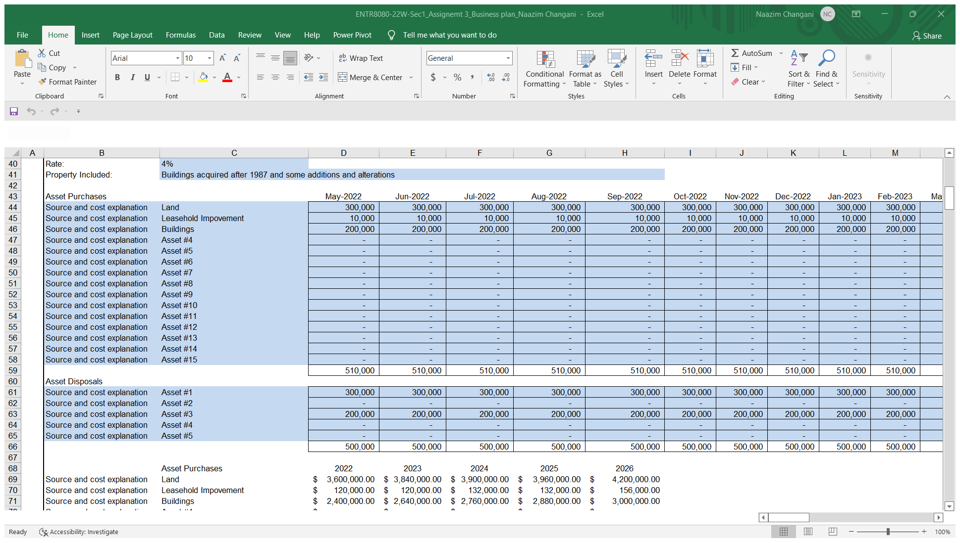

Table 4. Projected Assets Purchases for Years 1-4

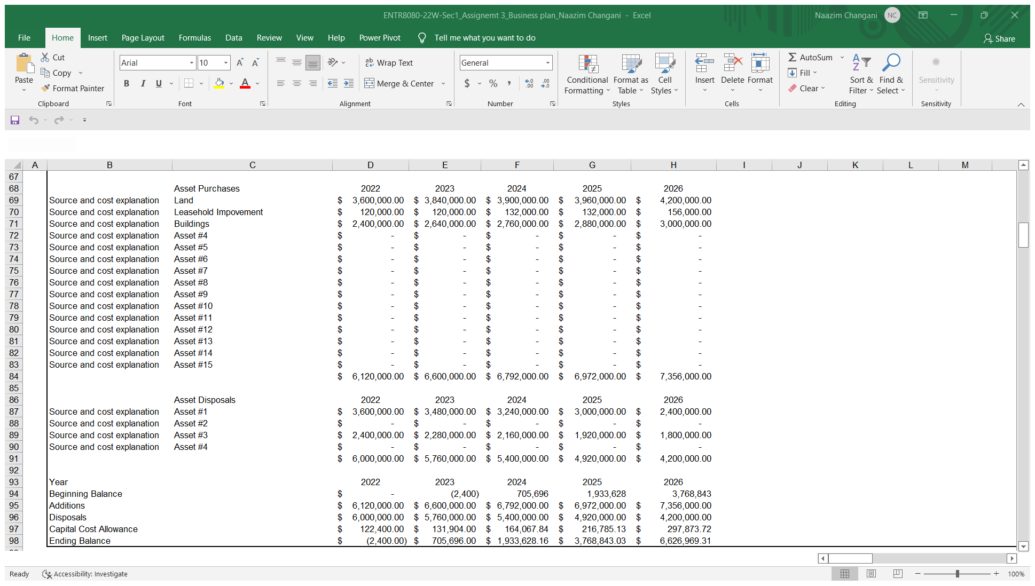

Table 5. Projected Assets Summary for Years 1-5

### Facilities

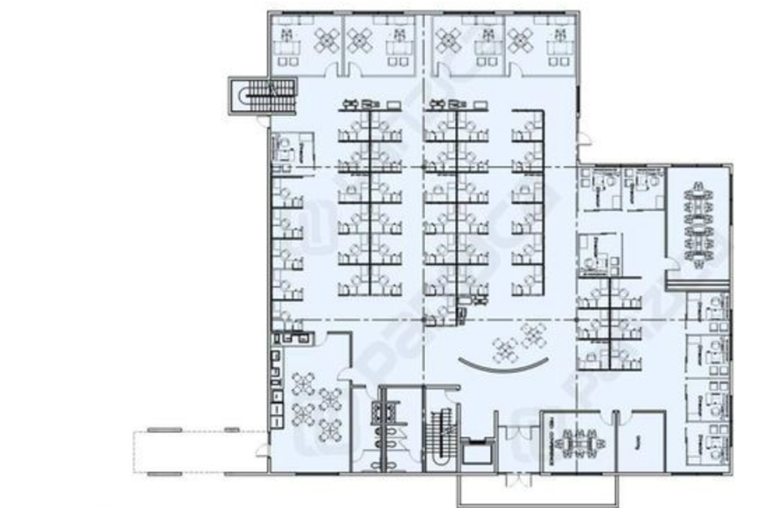

Figure 4. Office Layout

### Organizational Structure

Hayai Desire will be Non-profit Corporation organizational structure, a corporation is a separate legal entity from its owners, offering liability protection for each owner’s personal assets. Non-profit have specific corporation tax advantages, including the ability to file for nonprofit tax-exempt status with the state and federal governments.

Nonprofit corporations choose 501(c)(3) tax-exempt status, which exempts qualifying nonprofit corporations from having to pay federal and state taxes because the nonprofit corporation is pursuing a nonprofit mission

**Personal liability protection**

A corporation provides more personal asset liability protection to its owners than any other entity type. For example, if a corporation is sued, the shareholders are not personally responsible for corporate debts or legal obligations even if the corporation doesn't have enough money in assets for repayment. Personal liability protection is one of the main reasons businesses choose to incorporate.

**Business security and perpetuity**

Corporation ownership is based on percentage of stock ownership, which offers much more flexibility than other entity types in terms of transferring ownership and perpetuating the business for the long term.

Although specific details regarding transfer of ownership depend on the governing agreement in the bylaws and articles of incorporation, ownership of this entity type is often easy to buy and sell. For example, if an owner wants to leave a company, they can simply sell off their stocks. Similarly, if an owner dies, their ownership stocks can easily transfer to someone else.

**Access to capital**

Since most corporations sell ownership through publicly traded stock, they can easily raise funds by selling stock. This access to funding is a luxury that other entity types don't have. It is great not only for growing a business, but also for saving a corporation from going bankrupt in times of need.

**Tax benefits**

Although some corporations are subject to double taxation, other corporation structures have tax benefits, depending on how their income is distributed. For example, corporations have the luxury of splitting their income between the business and shareholders, allowing it to be taxed at different rates. Any income designated as owner salary will be subject to self-employment tax, whereas the remainder of the business dividends will be taxed at its own level.

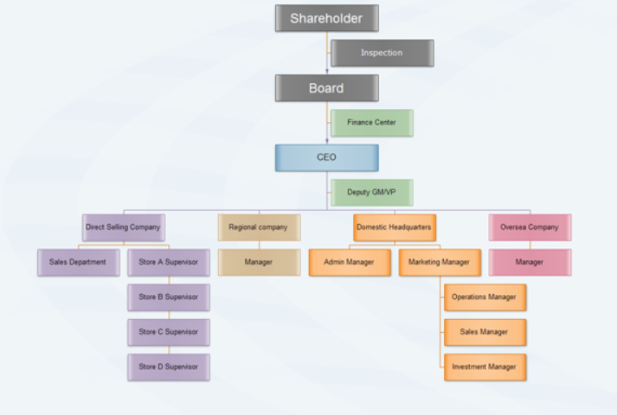

Figure 5. Organization Chart

## Human Resources Plan

Hayai Desire encourages employees to share their ideas and opinions openly during company-wide meetings and personal interviews with their managers, and while theirs may not always be implemented, employees still have a voice.

Hayai Desire has close to 20 full-time employees, but the bulk of their operations are carried out by their thousands of personal shoppers. Shoppers are typically underemployed individuals seeking flexible part-time work, such as students or mothers. They have the potential to earn $15-30 an hour through base salary and shopper tips.

Hayai Desire offers growth opportunities whether it’s a promotion or continuing education course, shows the employers is investing in their employee’s future this creates career path which can improve productivity and work engagement.

Hayai Desire work relationship are supportive and energizing, employees know their peers and managers are there to help them at work and are people they can genuinely trust.

Hayai Desire has a clear purpose and core value that resonate with their employees.

**Pay scale**: Hayai Desire provides reasonable market salaries for managers and non-managers.

**Vacation time**: This is not required by law but Hayai Desire offers vacation time to stay competitive and keep employees refreshed.

**Insurance:** Health insurance is a common staple benefit.

**Additional benefits:** Hayai Desire considers to include a life insurance plan, a 401k and matching funds, bereavement leave, religious and floating holidays and a potential bonus structure.

### Leadership and Management Strategies

Hayai Desire leadership philosophy is Delegate & Empower engage your team is to empower them by delegating greater responsibility, it can be exciting to be entrusted with a position of responsibility, makes you feel a sense of self-worth, gives that self-worth to others on your team

### Recruitment and Retention Strategies

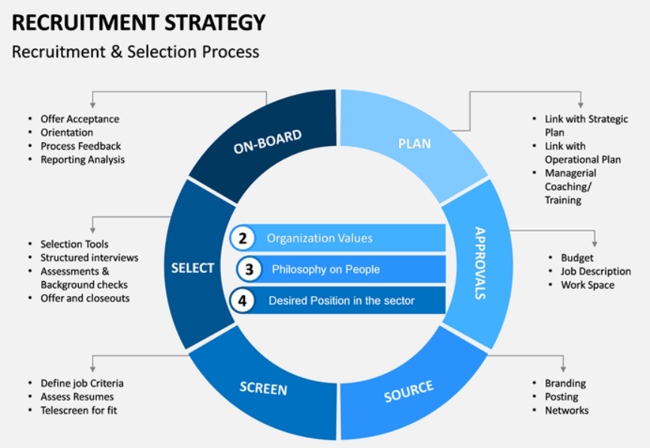

**The process of Recruiting Shoppers:**

Application is invited from individuals who want to earn money by shopping in their free time and work for Hayai Desire.

The applications are processed by the recruitment team and a face to face, one on one interview is scheduled.

Proper training is provided to selected individuals before they are ready to shop and deliver groceries.

**Hayai Desire retention strategies**

Shoppers can earn money by shopping & delivering on behalf of customers.

They receive an order on the shopper app.

Shoppers can work whenever they want. That means flexibility in working hours.

Two different working models: (1) Full-Service Shopper (2) In-store shopper

Full-Service Shopper: Shop for customers and also deliver to them. They work as an independent contractor. Hayai Desire pays $7 to $10 per order to the full-service shopper and a minimum $5 for delivery only works. Shoppers can also have tips from customers.

In-Store Shopper: Work as the part-time employee of the Instacart and shops only. They have to make an order ready for pick up.

### Training

Hayai Desire introducing three new mandatory trainings for all shoppers North America. Shoppers outside of North America will also have access to these trainings to complete if they choose.

These trainings include:

**Food safety:** Ensure you understand the fundamentals about how to keep perishable items fresh while shopping and delivering for your customers.

**Defensive driving**: Learn best practices for staying safe while driving.

**Sexual misconduct prevention and reporting**: Developed in partnership with RAINN, the nation’s largest anti-sexual violence organization, this training will help you learn to recognize and report sexual misconduct.

### Performance Appraisals

Hayai Desire uses a real-time feedback tool called DesireTick, which lets anyone working at the San Francisco start up leave real-time messages about any colleague's accomplishments. Feedback can be entered into a discrete website or proffered on the fly using a special e-mail plug-in.

### Health and Safety

At Hayai Desire, the health and safety of our entire community shoppers, customers and employees is our first priority. Our goal is to serve our customers when they need us and to offer a safe and flexible earnings opportunity to the shopper community, while also proactively taking the appropriate precautionary measures to operate safely with minimal disruption to our service.

**New Shopper Health and Safety Guidelines**

Hayai Desire worked closely with a panel of health and safety experts to develop a robust set of guidelines to ensure you’re able to continue shopping safely. Our goal is to make sure you have the resources you need to take the appropriate preventative actions and make use of precautionary food handling measures.

**Introducing Sick Pay for In-Store Shoppers**

Hayai Desire introducing a new sick pay policy for all in-store shoppers nationally to offer more support to this valued community. All Instacart part-time employees now have access to sick pay, an accrued benefit that can be used as paid time off if you are absent from work due to illness or injury.

**Extended Pay for Part-Time Employees & Full-Service Shoppers Affected by COVID-19**

In addition to sick pay for all in-store shoppers nationally, we’re also offering additional support for all part-time employees and full-service shoppers affected by COVID-19. We will offer up to 14 days of pay for any part-time employee or full-service shopper who is diagnosed with COVID-19 or placed in mandatory isolation or quarantine, as directed by a local, state, or public health authority. This assistance will be available for 30 days to ensure our community is supported during this rapidly evolving situation, and we’ll be sending more information to shoppers in the coming days. To the best of our knowledge, no one in our community has contracted COVID-19, but we believe this is the right thing to do for our employees and shoppers.

**Leave at My Door Delivery” Now Available**

“Leave at my Door Delivery,” a new feature originally designed to provide a more flexible option for customers that may not be home at the time of delivery. We’ve seen a significant surge in usage of this feature over the last few weeks, which is why we made the decision to roll “Leave at My Door Delivery” out to all Hayai Desire customers across North America.

### Compensation

In-store and full-service shoppers are paid weekly via direct deposit to a checking or savings account.

Full-service shoppers can use Hayai Desire Cash out, an immediate transfer to a debit card, to access their earnings more quickly. You can use Hayai Desire Cash out for the first time after completing five batches. After that, you can cash out at any time, as often as five times per day, as long as you have at least $5 in earnings. There’s a $3,000 daily limit.

Since full-service shoppers are considered independent contractors, they may have to make estimated quarterly tax payments. That’s because Hayai Desire doesn’t withhold taxes from earnings like it does for part-time employees.

In case of large orders which tends to be heavier, will likely result in more compensation than a small shopping job, and earning potential is usually higher when customer demand spikes, so working on Sundays and during popular events, like the Super Bowl can mean more money.

### Key Personnel

#### Mentors

* Successful entrepreneurs often have a cadre of business mentors, or coaches, that help them by providing needed advice. It can strengthen a business plan to indicate who the mentors and coaches are.

## Marketing Plan

### Market Analysis

The online grocery and grocery delivery market in the North American is a fast-growing industry and was experiencing this strong growth even before the COVID-19 pandemic. Over the past five years, the industry has maintained a compound annual growth rate of 7.4%, with revenues expected to reach 22.6 billion GBP by the end of 2021. When you consider that most of this growth had already been occurring prior to the acceleration brought on by the pandemic, the prospects for the industry look very promising. Furthermore, consumers in the North American have an incredibly strong affinity for delivery over pickup in terms of how they receive their online grocery orders, with 88% of consumers preferring to have their groceries delivered. This plays directly to Hayai Desires strengths and would serve as a strong way to position their services to consumers.

### Competitive Analysis

In terms of competition, the online grocery industry has 2325 businesses. The market is concentrated with Tesco, Asda, Ocado and Sainsbury holding 30.7%, 17.6%, 15.3% and 14.4% market share respectively, and all other competitors holding less than 5% market share. Tesco is a global company which offers groceries as well as other retail products such as cloths, home furnishings, etc. It has a high return on equity of 7% and operating margin of 3.9% at the end of 2020. Tesco uses multi-channel selling, operating over 7000 stores in Europe and Asia. They have seen decline in revenue in central Europe and Asia. Asda is a subsidiary of Walmart dealing with grocery and general merchandise. This means that Asda has strong support from Walmart's resources and has access to exclusive brands. However, Asda's reputation is at risk as they are currently undergoing the equal value lawsuit regarding unfair treatment of female employees. Ocado is an online grocery retailer that operates in 11 countries and has formed partnership with the 9 market leading grocery retailers. They have strong technological platforms, customer loyalty with 680,000 active customers, and revenue growth of 32.7% in 2020. However, they have high debt of almost 1000 million in 2020 that impacts profitability. Sainsbury's Supermarkets is a subsidiary of J Sainsbury that operates only in the UK through supermarkets and online. They had a revenue of over 31,000 million in 2020, but low margins and low brand loyalty.

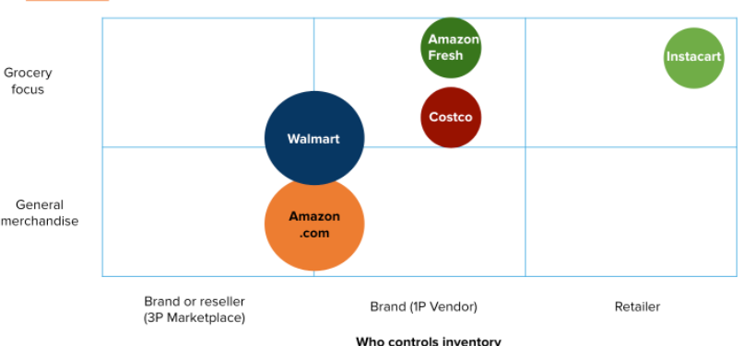

Figure 6. Positioning Map

|  |  |  |  |  |  |
| --- | --- | --- | --- | --- | --- |
| Company | Product Quality | Pricing score | Customer service | Culture score | Competitive Score |
| Hayai Desire | 3.2 | 3 | 3.2 | 85/100 | 8.3 |
| DoorDash | 3 | 3 | 3 | 63/100 | 7.3 |
| Postmates | 2.3 | 2.2 | 2.3 | 63/100 | 5.9 |

Table 6. Competitor Analysis

### Organizational Analysis

The four key elements of SWOT analysis are: Strengths, Weaknesses, Opportunities & Threats. Hayai Desire can use strengths to crate niche positioning in the market, can strive to reduce & remove weaknesses so that it can better compete with competitors, look out to leverage opportunities provided by industry structure, regulations and other development in external environment, and finally make provisions and develop strategies to mitigate threats that can undermine the business model of Hayai Desire.

## Strengths – Hayai Desire

Strengths are the Hayai Desire capabilities and resources that it can leverage to build a sustainable competitive advantage in the marketplace. Strengths come from positive aspects of five key resources & capabilities – financial resources, human resources, physical resources such as land, building, activities & processes, and past experience and successes.

**Strong relationship with existing suppliers** – As a new player in the industry, Hayai Desire should make strong relationship with its suppliers and other members of the supply chain. “Organization can increase products and services by leveraging the skills of its suppliers and supply chain partners” (According to John Deighton, Leora Kornfeld).

**Strong Balance sheet and financial statement** of Hayai Desire can help it invest in new and diverse projects that can further diversify the revenue stream and increase return on sales and other metrics.

**Superior product and services quality** can help Hayai Desire to further increase its market share as the current customer can be extremely loyal to it, there is evidences that with high quality of products and services, Hayai Desire can compete with other global players in the international market.

**Partnership and Expansion** – Hayai Desire can partner with a bunch of grocery shops including Costco, Sam’s club, Total Wines etc. Below is a list of retailer partnerships (CB Insights, 2018).

**Diverse Product portfolio** – Hayai Desire will not only offer grocery delivery but al so expand retail stores to include alcohol, where the shopper is requires to ID the customers for age limits. The drugstore and pet suppliers are also in high demand, among different generations, which shows a good range of diversity on products and customer base. Customers can also share their orders with family and friends.

**High Margins** – Hayai Desire can charge a premium compare to its competitors, this will provide Hayai Desire to not only thwart competitive pressures but also invest into research and development.

## Weaknesses – Hayai Desire

Weaknesses are the areas, capabilities or skills in which Hayai Desire lacks. It, limits the ability of the firm to build a sustainable competitive advantage. Weaknesses come from lack or absence of five key resources & capabilities – activities & processes, human resources, physical resources such as land, building, past experience and successes and financial resources.

**Inventory management** – Hayai Desire is a new enter in the industry, thus is not efficiently managing the inventory and cash cycle, there is a huge scope of improvement in inventory management.

**Customer Dissatisfaction** – Even though demand for product have not gone down but there is a sense of dissatisfaction among customers of Hayai Desire. It can be reflected on the review on various online platform. Hayai Desire should focus on areas where it can improve customer purchase and post purchase experience.

**Lack of critical talent** – Hayai Desire is suffering from lack of critical talent especially in the field of technology & digital transformation, Hayai Desire is struggling to restructure processes in light of development in the field of Artificial intelligence (AI) and machine learning.

**Store Coupons/Rewards and additional pricing** – Hayai Desire doesn’t allow applying coupons on the ordering app. Even through there has been a significant increase in the coupon’s usage from mobile devices, there is high and growing demand for coupons.

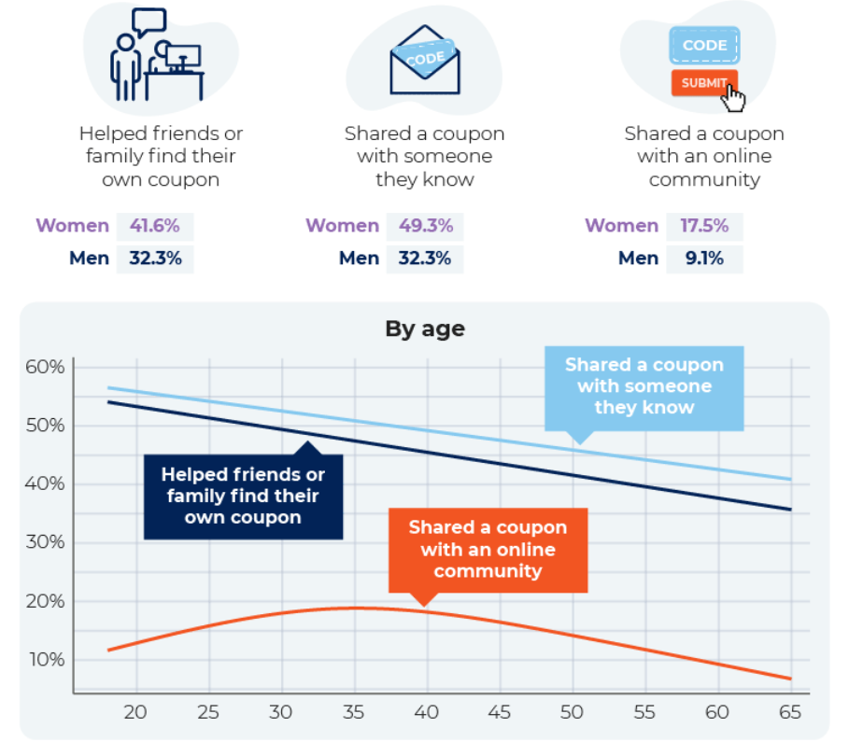

Source: shopper.com

**Mismatch on item delivered and customer choice** – As more runners/shoppers are being added to the Hayai Desire service, the quality of grocery and preference of customer goods can decline.

## 

## Opportunities – Hayai Desire

Opportunities are Marco environment factors and developments that Hayai Desire can leverage either to consolidate existing market position or use them for further expansion. Opportunities can emerge from various factors such as: economic growth, changes in consumer preference, technological innovations, increase in consumer disposable income, and political developments & policy changes.

**Increase in consumer disposable income** – Hayai Desire can use the increasing disposable income to build a new business model where customers start paying progressively for using its products, Hayai Desire can use this trend to expand in adjacent areas.

**Changing technology landscape** – Machine learning and Artificial intelligence boom is transforming the technology landscape that Hayai Desire operates in, Hayai Desire can use these developments in improving efficiencies, lowering costs, and transforming processes.

**E-commerce and social media-oriented business model** – E-commerce business model can help Hayai Desire to tie up with local suppliers and logistics provider in international market. Social media growth can help Hayai Desire to reduce cost of entering new market and reaching to customers at a significantly lower marketing budget.

**Development in Artificial intelligence** – Hayai Desire can use development in Artificial intelligence to better predict consumer demand, cater to niche segments and make better recommendation engines.

**Growing market size and evolving preference of consumers** – Over the last decade and half the market size has grown at brisk pace. The influx of new customers has also led to evolution of consumers preference and tastes. Hayai Desire should diversify using different brands and then by adding features based on customer preferences.

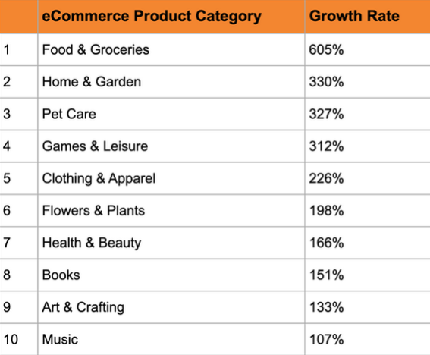

Source: Wix.com-Growth rate

**Access to international Talent in global market** – Expansion into international market can help Hayai Desire to tap into international talent market, it can also help in brining the talent into domestic market and expanding into new areas.

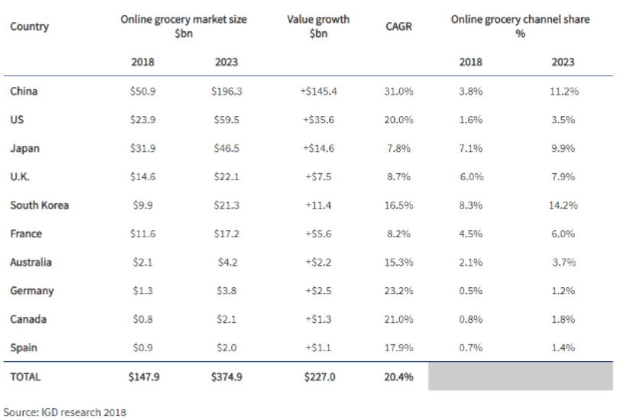

International growth Opportunities

## Threats – Hayai Desire

Threats are Marco environment factors and developments that can derail business model of Hayai Desire. Threats can emerge from various factors such as: technological innovations, political developments & policy changes, changes in consumer preference and economic growth.

**Threats of new entrants because of recusing costs and increasing efficiencies** – As Hayai Desire can leverage low cost of reaching customers using social media and e-commerce, so can the competitors both local and international competitors.

**Increasing costs components for working in developed market because of environment regulations** - Hayai Desire has to deal with this cost as government are trying to levy higher environment taxes to promote cleaner options, for Hayai Desire it may result into higher logistics costs and higher packaging costs.

**Government regulations** – Hayai Desire should keep a close eye on the fast-changing government regulations under the growing pressure from protest groups and non-government organization especially regarding to environment and labor safety aspects.

**Well established competitors** – Currently every retail store has started their own delivery models such as Amazon buying wholefoods and utilizing Amazon fresh, Walmart, or Target buying ship. These companies not only have a strong customer base, but they are also backed by strong financials.

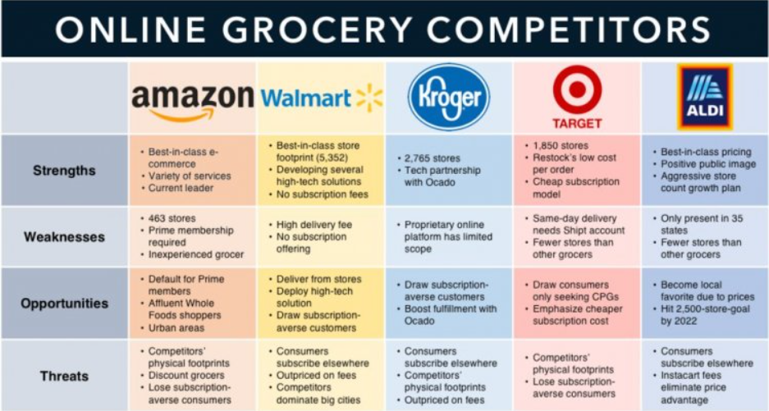

Competitive SWOT Analysis

**Recommendations**

SWOT analysis clarifies the current standing of Hayai Desire. Few necessary improvements are needed to be done to administer the lacking and reinforce its market position.

In short, Hayai Desire needs to strengthen its key areas, minimize its weakness, avail opportunities, and counteract threats for future progress.

1. Consolidate the market dominance by boosting its marketing efforts, promotional activities, and competitive advantages.
2. Increase its limited presence through opening physical stores outside the US. This will augment brand popularity and market reach.
3. Enhance its strategic entry in developing countries where many growth opportunities are available.
4. Improving the issues of cybercrime by upgrading technology measures.
5. Enhance network security system for the protection of consumer’s right.

# Core Competencies

The company’s main objective is to recognize that competition between companies is as much a race for the competition as it is for the marketplace situation and market authority. Consequently, the purpose for the organization of Hayai Desire is to focus on competencies that affect competitive advantage.

* Innovative infrastructure and logistics for fast delivery.
* Superior product and service quality.
* Robust domestic market that Hayai Desire operates in.

**Fast delivery**: With fast delivery, like same-day or next-day shipping, it removes one negative from online shopping. If the customers are satisfied with expedited shipping, they are likelier to continue to make purchase from Hayai Desire. For whatever reason the customer needs expedited delivery, having it can relieve great stress.

**Super product and service quality**: Product and services that meet or exceed customer expectations results in customer satisfaction. Quality is the expected product/services being realized. However, quality is a function of how the customer views the products/services that he or she receives.

**Robust domestic market**: The domestic market in which Hayai Desire operates is both a source of strength and roadblock to the growth and innovation of the company, Hayai Desire will grow in its domestic market without much innovation but will require further investment into research and development to enter international market.

### Marketing Strategy

For successful marketing strategy at Instacart Grocery, the marketing managers need– understanding of customers’ fundamental needs and drivers of those needs, conceptualizing products and services that can meet those needs and are feasible in Hayai Desire financial and intellectual resources, and finally developing marketing mix for entire go-to market strategy.

Increase sales of Hayai Desire– The goal of marketing efforts is to increase sales of the present products. It may involve selecting a new target segment or positioning an existing product differently to a new segment.

Get existing customers of Hayai Desire to buy more – It often involves selling accessories along with the existing products or increase the usage rate of the existing products. Increase usage rate is comparatively a difficult task even with a war chest of huge marketing resources.

Increase market share of Hayai Desire– Marketing efforts can be used to increase market share either by driving increase in sales to new customers or by driving higher sales to existing customers.

Improve customer loyalty of Hayai Desire customers – Marketing efforts can be used to increase loyalty among existing customers by organizing events, and by providing post purchase information and services.

Bring in new customers to Hayai Desire– It may involve launching version of product that can appeal to new segment of customers or entering into new markets.

Better establish the brands of Hayai Desire– Brand awareness and positioning is one of the critical objectives of marketing and often organization spend a significant part of marketing budget on brand positioning.

Introduce a new product or service of Hayai Desire– It is the traditional function of marketing mix – launching a new product and communicating its features, superior value proposition, and uniqueness.

The first stage of the marketing process at Hayai Desires to do research and analysis to identify unmet and even unknown customer needs.

Customer’s Needs– What are the needs that Hayai Desire seek to satisfy. Who are the present customers and who are the potential customers for the new product or service.

Company – What are the resources and special skills that Hayai Desire needs to possess to create products that can fulfil the needs of the prospective customers. Check out the detailed SWOT Analysis for Hayai Desire on the following page.

Competitors – Who are the competitors in the target market and what value proposition they are offering in the market place. Do they possess enough financial and knowledge resources to develop new products to compete with Instacart Grocery.

Collaborators – What sort of supply chain and value chain partners Hayai Desire needs to develop and deliver new product to final consumer. What are the respective bargaining powers of value chain partners.

**Target Customer Segment**

Market segmentation is the process through which marketing managers at Hayai Desire can divide the large market into smaller segments based on distinct needs, characteristics, or consumer behavior. Hayai Desire can do segmentation based on following criteria – geographic, demographic, usage, user status, income, lifestyle, value proposition priorities, benefits sought, loyalty status, gender, social class, self-perception, psychographic factors, and other attitudes.

Once the overall market is divided into various segments then Hayai Desire needs to choose a target segment or few target segments. The key is not to be everything to everybody as the products can only deliver specific value proposition.

**Differentiation & Positioning**

Differentiation process involves how Hayai Desires differentiating its products and services in the market place compare to its competitors. Positioning is the position of the brand or Hayai Desire products in minds of target customers – based on distinctive features, qualities and functions.

The differentiation and positioning task at Hayai Desire require marketing managers to do -

Identify competitive advantage or unique value proposition on which position the brand in the mind of the consumers.

Choose competitive advantages that are most compatible with Hayai Desire marketing strategy. Marketing managers at Hayai Desire can make perceptual maps to better understand competitive positioning of various brands in the market place.

Finally Positioning the brand as a deliverer of superior value to the target segment and effectively communicating that position to consumers using marketing mix and promotion mix.

**Capturing Value**

Product - Understand the deep-seated drivers of perceptions and behavior of consumers and develop a product that appeal to those drivers.

Place – Evaluate the buying behavior and distribution channel costs to make a channel decision.

Promotion - Engage with customers through use cases and benefits instead of functionalities and features. Communication should be focused on experience rather than product features.

Price – Price is often determined by marketing strategy, cost structure of the company, competitive positioning of firm, brand positioning, and various other factors. If the business model is built on conversion of existing customers, then Hayai Desire needs to arrive at a price through research at which the present customers are willing to switch to a new brand.

**Post Purchase Services – Sustaining Value**

Even though the number varies, the efforts taken to gain new customers are far more and costly than those to keep the present customers loyal. Post purchase services are critical to foster loyalty among the customers. Various ways in which Hayai Desire can improve the post purchase experience of the existing customers:

Providing installation and other related services.

Taking regular feedback from customers and asking them how certain features can be enhanced.

Providing regular maintenance services and spare parts, if the customer needs them.

Providing product care tips.

Building communities where customers can share experience and help other customers.

Post purchase services are critical not only to foster loyalty among the customers but also to get continuous feedback and improve the products.

in terms of competition, the online grocery industry has 2325 businesses (IBISWorld,

2020). The market is concentrated with Tesco, Asda, Ocado and Sainsbury holding 30.7%,

17.6%, 15.3% and 14.4% market share respectively, and all other competitors holding less than

5% market share (Business wire, 2020).

Tesco is a global company which offers groceries as well as other retail products such as

cloths, home furnishings, etc. It has a high return on equity of 7% and operating margin of 3.9%

at the end of 2020 (MarketLine, 2021b). Tesco uses multi-channel selling, operating over 7000

stores in Europe and Asia (MarketLine, 2021b). They have seen decline in revenue in central

Europe and Asia. Asda is a subsidiary of Walmart dealing with grocery and general merchandise

(MarketLine, 2021c). This means that Asda has strong support from Walmart's resources and has

access to exclusive brands. However, Asda's reputation is at risk as they are currently undergoing

the equal value lawsuit regarding unfair treatment of female employees (MarketLine, 2021c).

Ocado is an online grocery retailer that operates in 11 countries and has formed

partnership with the 9 market leading grocery retailers (MarketLine, 2021d). They have strong

|  |  |  |
| --- | --- | --- |
| Hayai Desire Gift card | Hayai Desire Home Banners | Hayai Desire Express Code offer |
| Spanning Multiple Orders promo | Dollar Off Promotion | Free item Promotions |
| Personalized Retailer Discount | PayPal Promotion | Apple Pay Promotion |
| T-Mobile Tuesday promotion |  |  |

Table 7. Promotional Plan Years 1-2

|  |  |  |  |
| --- | --- | --- | --- |
| Year 2022 | Goal | Actual | Variance |
| January | 199 | 145 | -27.1% |
| February | 166 | 238 | 43.3% |
| March | 204 | 152 | -25.5% |
| April | 224 | 291 | 29.9% |
| May | 290 | 158 | -45.5% |
| June | 138 | 272 | 97.1% |
| July | 154 | 255 | 65.5% |
| August | 268 | 207 | -22.8% |
| September | 294 | 284 | -3.4% |
| October | 249 | 213 | -14.5% |
| November | 153 | 278 | 81.7% |
| December | 286 | 148 | -48.5% |
|  | 2,625 | 2,641 | 0.6% |

Table 8. Projected Sales Years 1-3

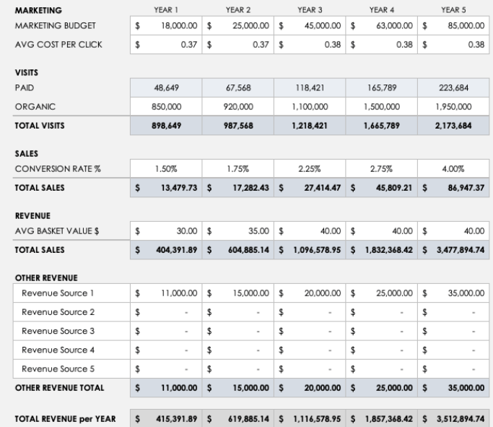

Table 9. Projected Sales Summary for Years 1-5

## Financial Plan

It is nearly certain you will need to make monthly cash flow projections for five years from business inception. This is nearly the only way to clearly estimate your working capital needs and, specifically, important things like the times when you will need to draw on or can pay down your operating loans and the months when you will need to take out longer-term loans with which to purchase your fixed assets. Without a tool like this, you will be severely handicapped when talking with bankers about your expected needs. They will want to know how large of a line of credit you will need and when you anticipate needing to borrow longer-term money. It is only through doing cash flow projections will you be able to answer these questions. You also need this information to determine things like any needed changes to your required loan payments and when you can take owner draws or pay dividends.

Your projected cash flows enable you to develop your projected income statements and balance sheets.

### Overview

* You should introduce the financial plan section of your business plan with a comprehensive overview that describes how you developed this section.

### Proforma Income Statements

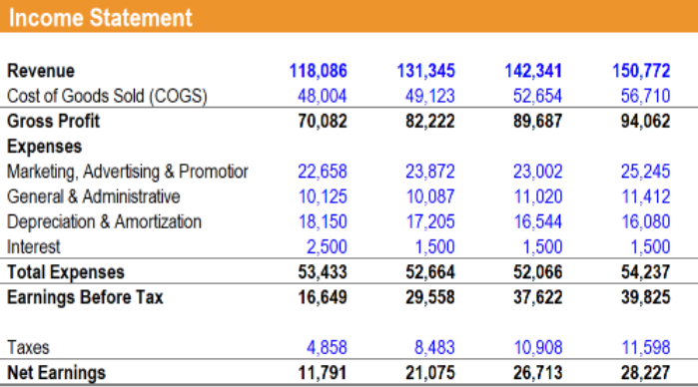

Table 10. Projected Income Statements

### Proforma Balance Sheets

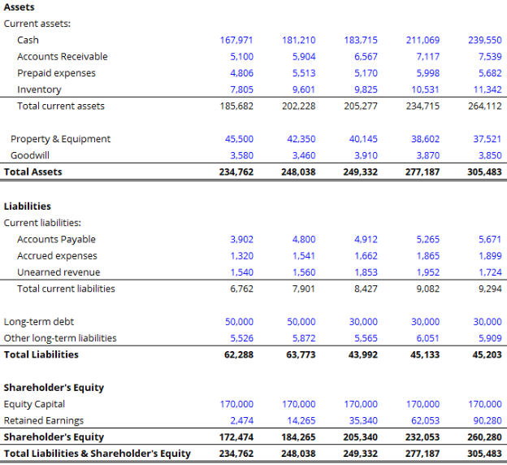

Table 11. Projected Balance Sheets

### Proforma Cash Flow Statements

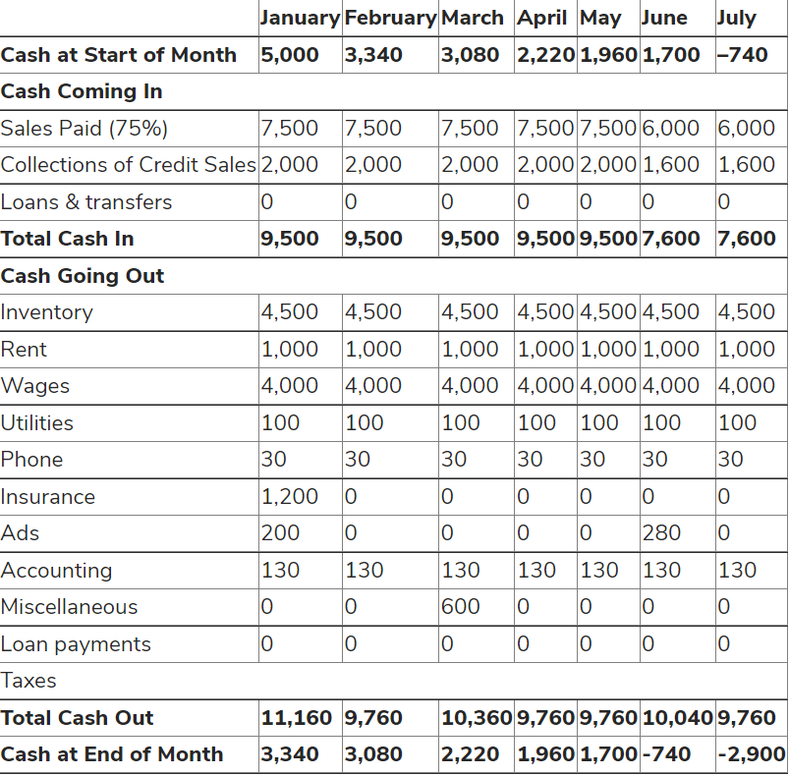

Table 12. Year 1 Projected Cash Flow Statement

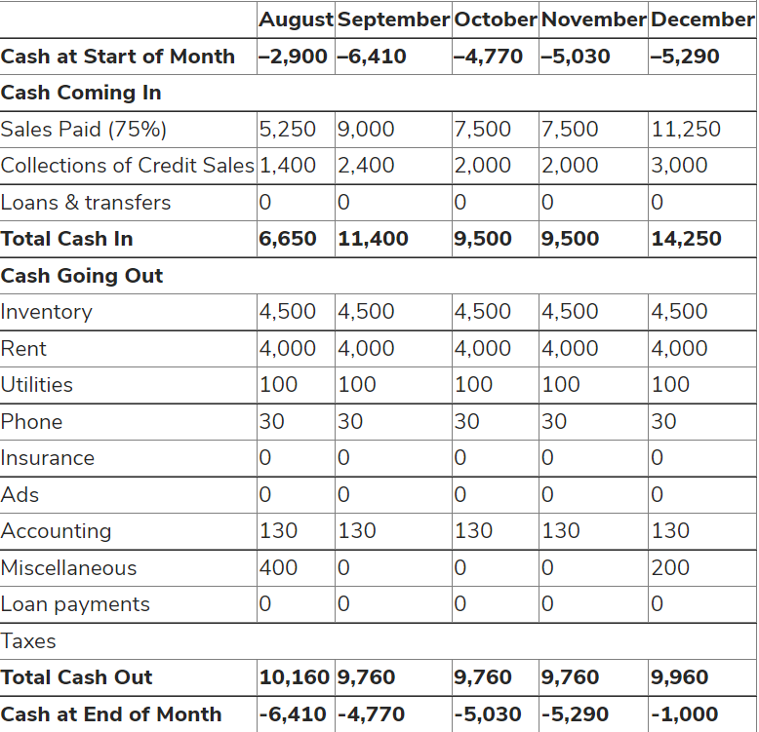

Table 13. Year 2 Projected Cash Flow Statement

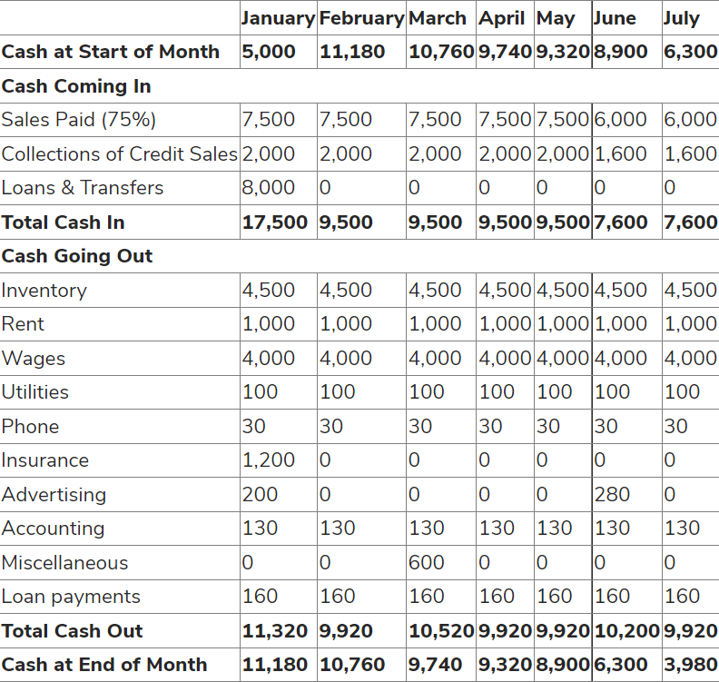

Table 14. Year 3 Projected Cash flow Statement

### Investment Analysis

### Projected Financial Ratios and Industry Standard Ratios

|  |  |  |  |
| --- | --- | --- | --- |
| Ratio Analysis | Purpose | Formula | Ratio |
| Current Ratio | The measure the extent to which current assets are available to meet current liabilities. | Total current asset/ Total current liabilities | 1.5 |
| Quick Ratio | Measure the ability to pay credit demand | (Total current assets – total inventory)/ total current liabilities | 2.0 |
| Fixed Asset | Measure sales ratio | Sales revenue/ total assets | 1,700 |
| Debt-to-Equity | Number of dollars of borrowing for each equity investment | Long term debt/ total stakeholders’ equity | 1 |
| Net profit margin | Percentage of net profit | Net opening profit after tax/ sales revenue | 3,980 |
| Return on Total assets | Number of dollars earned | Income/total assets | 15% |
| Return on Equity | Number of incomes against total shareholder equity | Net income after tax/ total stakeholders’ equity | 18% |

Table 15. Projected Financial Ratios

### Break-Even Analysis

Fixed cost = $132,000 Variable cost = $2,424 Average price = $2500

Break-Even Point

=Fixed cost/ (Average Price – Variable Costs)

= 132000 / (2500 - 2424)

= 1,736.8

|  |  |  |  |  |  |  |
| --- | --- | --- | --- | --- | --- | --- |
| (1)  Units | (2)  Average cost per unit | (3)  Average selling price per unit | (4)  Total fixed costs | (5)  Total variable costs (column 1 x column 2) | (6)  Total costs (column 4 + column 5) | (7)  Sales (column 1 x column 3) |
| 169 | 13 | 20 | 20,000 | 2,197 | 22,197 | 3,380 |
| 289 | 12 | 18 | 19,000 | 3,468 | 22,468 | 5,202 |
| 300 | 14 | 19 | 21,000 | 4,200 | 25,200 | 5,700 |
| 450 | 11 | 16 | 17,000 | 4,950 | 21,950 | 7,200 |
| 516 | 15 | 20 | 25,000 | 7,740 | 32,740 | 10,320 |
| 700 | 17 | 25 | 30,000 | 11,900 | 41,900 | 17,500 |
|  |  |  |  |  |  |  |

Table 16. Break-Even Analysis

### Critical Success Factors

Although there are many benefits of using Hayai Desire, there are factors impacting business

Currently unavailable in many rural areas, which ay be due to a lack of grocery stores or Hayai Desire shoppers.

May be more expensive than in-store shopping due to higher priced items and delivery and service fees.

Difficult to use for those who have limited experience using technology or lack access to the internet or a smartphone.

## References

References

Stats Link Canada. (2009). Financial performance indicators for Canadian business. Retrieved from <http://www.gdsourcing.ca/FPI-Small.PDF>

SaVanna Shoemaker, MS, RDN, LD and Rachael Link, MS, RD, October 2019, Pro, COns and is it worth the price, https://www.healthline.com/nutrition/instacart-review

Tom Crosthwaite, July 28 2020, Seller & Vendor Cental, https://blog.bobsledmarketing.com/blog/an-introduction-to-instacart-for-brands

Viktor, July 5 2021, Instacart Business Model, https://productmint.com/the-instacart-business-model-how-does-instacart-make-money/#:~:text=Executive%20Summary%3A&text=Instacart%20makes%20money%20via%20commissions,America's%20leader%20in%20grocery%20deliveries.

Gina Acosta, September 10 2020, The predictable rise of Instacart, https://progressivegrocer.com/predictable-rise-instacart

Applied Economics, February 2022, Investment analysis, https://www.researchgate.net/publication/358423367_Sectoral_investment_analysis_for_Saudi_Arabia

Paresh Sagar, March 2020, Business Model: Insigth, https://www.apurple.co/instacart-business-model/#:~:text=Instacart%20implements%20sharing%20economy%2Dbased,their%20products%20on%20the%20platform.

Neal A Akyildirim, Feb 6 2020, Exploratory Analysis, https://towardsdatascience.com/instacart-exploratory-analysis-fdd5e3f9bf60

Leadership Articles, December 1 2016, Leadership Strategies Proven to improve performance, <https://crestcom.com/blog/2016/12/01/5-leadership-strategies-to-improve-performance-in-your-company/>

## Appendix 1. Owner Biographies

Naazim Changani currently a student at Conestoga college perusing Financial technology.

## Appendix 2. Product Pictures

